Exercise Sheet: Geographical information about the Hase
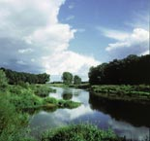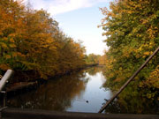

The Hase is a 193 km long river in Lower Saxony. It is a tributary of both the Ems and the Else (part of the Weser basin). Its source can be found in the Teutoburger Forest which is located south-east of Osnabrück. More precisely, the river springs from the North slope of the 307 m high Hankenüll hill.
After approximately 15 km, the Hase encounters an anomaly of terrain and bifurcates near Gesmold: Each branch flows in a different drainage system. One third of its waters flow along the sough side of the Wiehengebirge hills eastwards from Gesmold into the Else. After that, the water flows into the Werre at Kirchlengem (north of Herford). The Werre is a tributary of the Weser. Two thirds of the Hase´s waters flow northwest from Gesmold to Osnabrück and pass various towns. These are:
- Melle
- Osnabrück
- Bramsche (to the south of Bramsche, the Hase crosses the Mittellandkanal)
- Neunkirchen-Vörden
- Bersenbrück
- Quakenbrück (in the southeast, the Hase divides into two branches: the Big Hase (passing the town in the northeast) and the Little Hase (which itself is divided into two branches within the town (Binnendelta))
- Menslage (it is here where the Hase is channeled into the Little Hase)
- Löningen (here, it flows into a northerly branch)
- Herzlake (here, the two branches flow together again)
- Haselünne
- Meppen

Exercises:

1. Find the course of the river Hase in an atlas.
2a. Produce a map of Germany in which you draw in the course of the river Hase.
2b. Produca a map of Lower Saxony in which you draw in the course of the river Hase in
more detail than in the first map. The cities which are listed above should be on this map.

